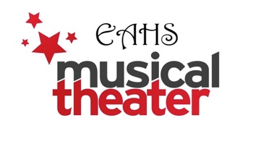
DONATION FORM: Mail or deliver this form with check to:
EMTB (Easton Musical Theatre Boosters) c/o James Vivian
Easton Area High School, 2601 William Penn Highway, Easton, PA 18045

Name of student: _______________________________

Name of donor or business: _________________________________________________

Email: __________________________________ Amount Donated: $ ________________

Please make checks payable to EMTB. Thank you! Detach here______________________

ADVERTISING FORM
Our musical this year is the high energy, pop-rock comedy, “Legally Blonde”! Advertise your business in our program as 2500 copies will be distributed throughout our 4 shows: March 12th - 15th 2026.
Please email the add in digital form to vivianj@eastonsd.org by February 10th!
Mail check & form to: Easton Area High School, 2601 William Penn Highway, Easton, PA 18045.
Return this form with your check by February 10th! Your student may also bring the add/check (or cash) to rehearsal/tech or drop off in Mr. Vivian’s mailbox in Main Office. Please make checks payable to EMTB (Easton Musical Theatre Boosters).

- ___ Quarter page ad - $35.00 (business card, B&W)
- ___ Half Page ad - $75 (4”Hx5W”, B&W)
- ___ Full Page ad - $100 (8”Hx5”W, B&W)
- ___ Inside cover or back page ad (8’x5”) - $300 for all 4 shows.
Ads can be shrunk or enlarged, but not altered. TIFF or PDF preferred.

Business Information:
Name of Business ____________________________________________________
Business contact: _____________________________________________________
Address: ____________________________________________________________
Phone # _______________________Name of student who sold ad: _____________________
___ Please check if you would allow us to have a donation bin at your place of business.
Thank you for supporting students of the EAHS Musical Theatre Company!

