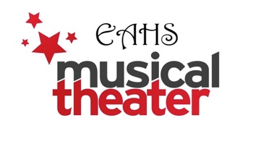
Easton Area High School Musical Theatre
“Legally Blonde” Patron Donations

Please support our students in their endeavors to produce a stage musical at Easton Area High School for 2026. We are offering you the opportunity to support our students’ success and love of the arts through patron sponsorship. All patrons will be listed by category in the program, which will be distributed at each performance of this year’s musical, “Legally Blonde”.

Check One:
______ Premiere Club - $1,000.00 or more
(Includes four complimentary tickets to performance of your choice)
______ Producer’s Club - $500.00 or more
(Includes two complimentary tickets to performance of your choice)
______ Director’s Club - $250.00 or more

______ Standing Ovation! - $100.00 or more

______ Bravo! - $75.00 or more
______ Applause! - $50.00 or more
______ Actor’s Guild - $35.00 or more
______ Chorus - $20.00 or more
TOTAL AMOUNT ENCLOSED: $________

ONLY PATRON NAMES will be listed. No logos or messages will be printed.

Name as you would like it to appear in the program: __________________________________
(Please Print)
Thank you for your generous support. Seller’s Name: _________________________________

Please make checks payable to EMTB (Easton Musical Theatre Boosters). Mail check & form to: Easton Area High School, 2601 William Penn Highway, Easton, PA 18045 c/o Mr. Vivian. Return this form with your check by February 10th! Your student may also bring the form with check/cash to rehearsal/tech or drop off in Mr. Vivian’s mailbox in Main Office.
Questions: vivianj@eastonsd.org

